**Mawlana Bhashani Science and Technology University**

Department of Information and Communication Technology

Santosh, Tangail - 1902



LAB REPORT

**Lab Report No:** 01

**Lab Report Name:** Generate various types of signals using MATLAB.

**Course Code:** ICT - 4206

**Course Title:** Digital Signal Processing Lab

|  |  |
| --- | --- |
| **Submitted By** | **Submitted To** |
| Name : Tusar Sarker | Dr. Monir Morshed |
| ID : IT- 16015 | Professor |
| Session : 2015-16 | Department of ICT, MBSTU |
| 4th Year 2nd Semester |  |
| Department of ICT, MBSTU |  |

**Experiment No:** 01

**Experiment Name:** Write a MATLAB program to plot the following Continuous time & Discrete time signals.

1. Step Function
2. Impulse Function
3. Ramp Function
4. Exponential Function

**Source Code:**

clc;

clear all;

n=-10:1:10;

x=(n>=0);

subplot(321)

stem(n,x,'b')

xlabel('n values');

ylabel('amplitude x(n)');

title('step Function');

x=(n==0);

subplot(322)

stem(n,x,'b')

xlabel('n values');

ylabel('amplitude x(n)');

title('impulse Function');

x=(n>=0).*n;

subplot(323)

stem(n,x,'b')

xlabel('n values');

ylabel('amplitude x(n)');

title('Ramp Function');

%e^an

subplot(324)

%x=exp(n)

a=2;

x=exp(n);

stem(n,x,'b')

xlabel('n values');

ylabel('amplitude x(n)');

title('exponential Function');

**Output:**

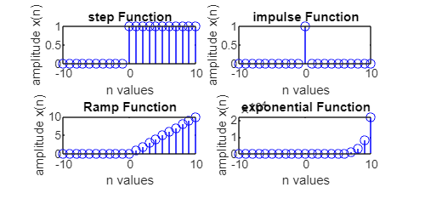

**Experiment No:** 02

**Experiment Name:** Write a MATLAB program to perform amplitude scaling, time scaling and time shifting on a given signal.

**Source Code:**

clc;

clear all;

close all;

xn=[1 2 3 4 5];

a=2;

N=length(xn);

n=0:1:N-1;

subplot(321)

stem(n,xn)

xlabel('n values');

ylabel('amplitude x(n)');

title('orginal sequence');

subplot(322)

stem(n-a,xn)

xlabel('n values');

ylabel('amplitude x(n)');

title('time shifting');

subplot(323)

stem(n,xn*a)

xlabel('n values');

ylabel('amplitude x(n)');

title('amplitude scaling');

subplot(324)

stem(a*n,xn)

xlabel('n values');

ylabel('amplitude x(n)');

title('time scaling');

**Output:**

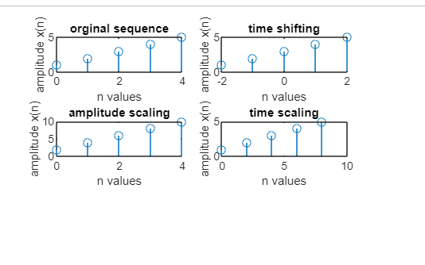

**Experiment No:** 03

**Experiment Name:** Convolution of given signals a. Write a MATLAB program to obtain linear convolution of the given sequences.

1. Write a MATLAB program to compute autocorrelation of a sequence x(n) and verify the property.
2. Write a MATLAB program to compute crosscorrelation of sequences x(n) and y(n) and verify the property.

**Source Code:**

clc;

clear all;

close all;

xn = [1 2 3 4 5];

hn = [1 2 3 4 5];

yn = conv(xn,hn);

subplot(321)

stem(yn);

xlabel('n values');

ylabel('amplitude x(n)');

title('convulation sequence');

yn1 = xcorr(xn,xn);

subplot(322)

stem(yn1);

xlabel('n values');

ylabel('amplitude x(n)');

title('auto correlation');

yn2 = xcorr(xn,hn);

subplot(323)

stem(yn2);

xlabel('n values');

ylabel('amplitude x(n)');

title('cross correlation');

**Output:**

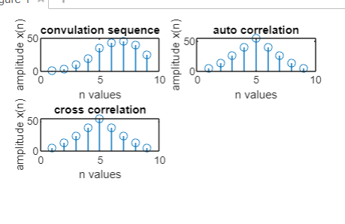

**Experiment No:** 04

**Experiment Name:** Calculate and plot Z transform of a given signal.

**Source Code:**

clc;

clear all;

close all;

xn=[1 2 3 4 5];

s=0;

N=length(xn);

z=sym('Z');

for i=0:N-1

s=s+xn(i+1)*z^(-i);

end

disp('Z transform of xn is:');

disp(s);

**Output:**

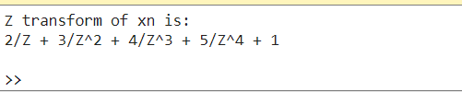

**Experiment No:** 05

**Experiment Name:** Evaluate DFT of a given sequence using MATLAB.

**Source Code:**

clc;

clear all;

close all;

xn = [1 2 3 4];

yn=fft(xn);

disp('DFT if xn is:');

disp(yn);

**Output:**

